Arduino Data Report #3:

All sensors and laser, 0 mg/L

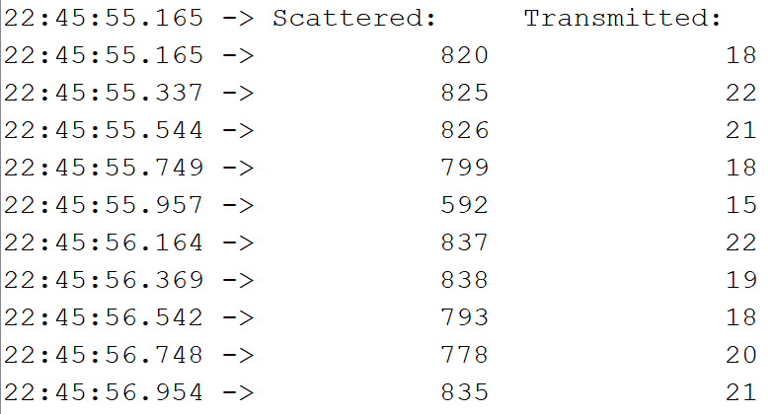

|  |  |  |
| --- | --- | --- |
| Sample | Avg. Scattered: | Avg. Transmitted: |
| No Sample | 809.2 | 18.7 |
| 0 mg/L of Kaolin Clay | 794.3 | 19.4 |
| 500 mg/L of Kaolin Clay | 805 | 24.9 |
| 1000 mg/L of Kaolin Clay | 841.8 | 23 |

All sensors and laser, 500 mg/L

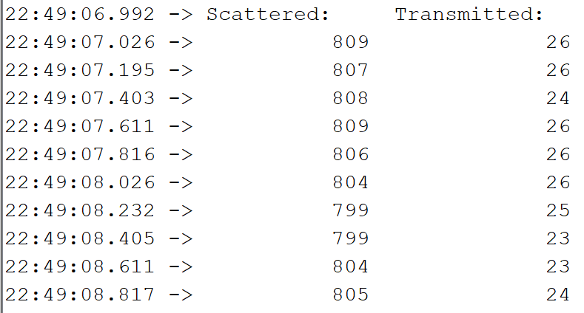

All sensors and laser, 1000 mg/L

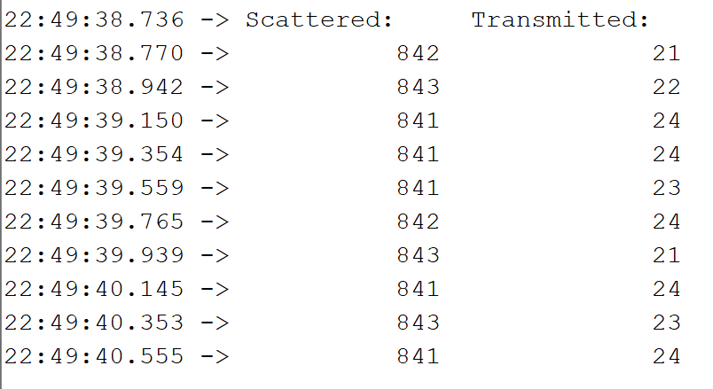

All sensors and laser, no sample

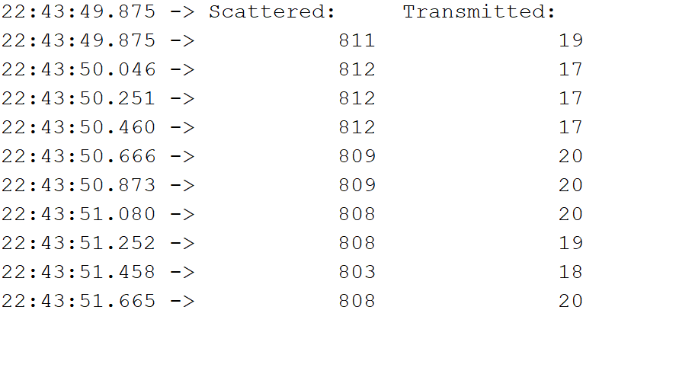

For 0 mg/L sample:

|  |  |  |
| --- | --- | --- |
| Set-Up | Avg. Scattered | Avg. Transmitted |
| No Laser | 837.6 | 15.3 |
| No Scattered Light Sensor | 838.8 | 14.6 |
| No Transmitted Light Sensor | 832.9 | 14 |

No laser w/ 0 mg/L

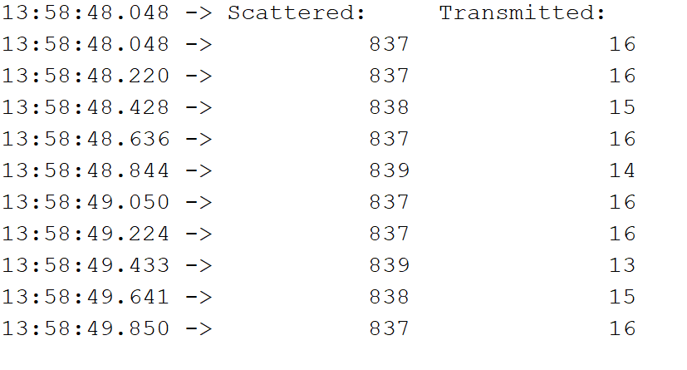

No scattered w/ 0 mg/L

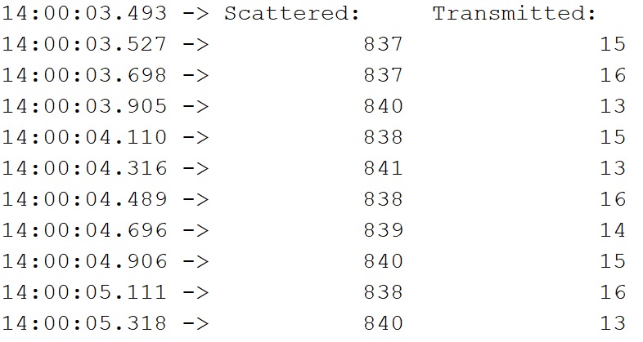

No transmitted w/ 0 mg/L

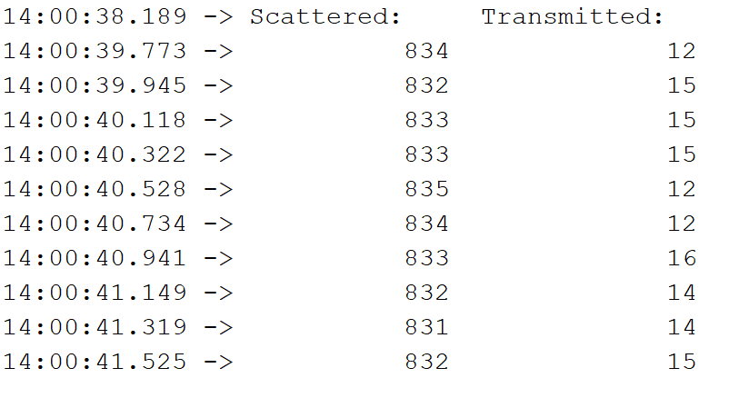

No Laser w/ 1000 mg/L

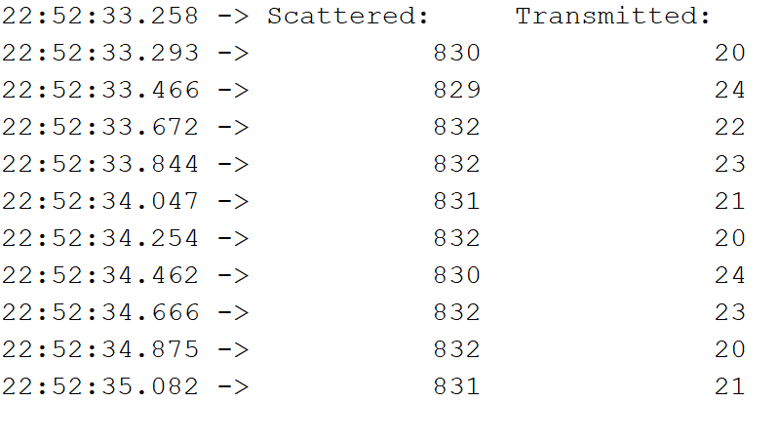

No Transmitted Sensor w/ 1000 mg/L

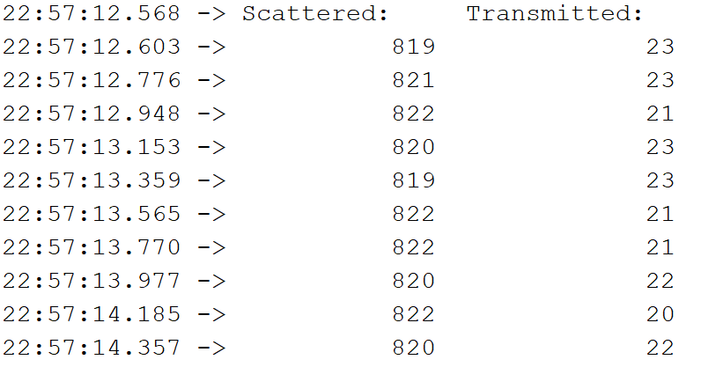

No scattered sensor w/ 1000 mg/L

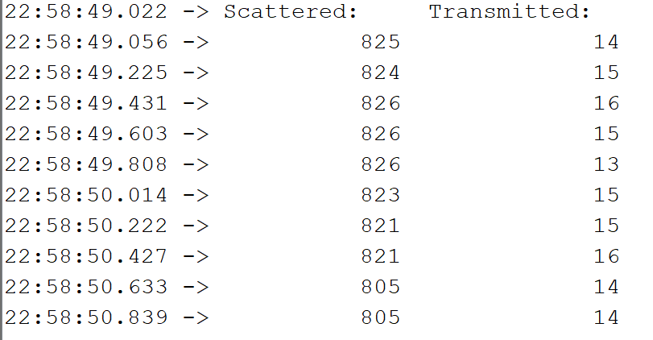

Play w/ circuit: from top to bottom: (unplugged white wire to 1-, unplugged A1 wire on circuit board, unplugged wire from A0 on circuit board)

